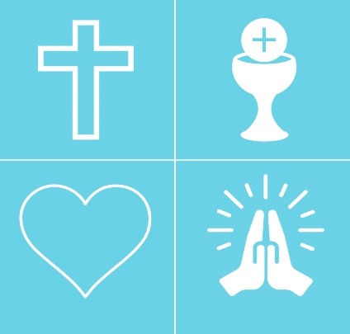
Our Lady Star of the Sea Catholic Church
Faith Formation Registration
& Medical Release Form
PLEASE RETURN COMPLETED FORMS TO THE PARISH OFFICE.

Please Note: Preparation for the Sacraments of First Reconciliation and First Communion is fulfilled through participation in our 2nd grade class!
Student Information and Background
Student Name (one student per form please!):________________________________________________________
Address:________________________________________________________________Zip Code:___________
Home Phone: __ __ _ Cell Phone:_____________________________
Gender: M or F Date of Birth: / / City/State of Birth:_______________________________
Grade: Age: _ __ School Name:_____________________________________
Parent/Guardian Information
Father’s Name: __ __ __ Father’s Cell:_________________________
Mother’s Name: __ ____ Mother’s Cell:________________________
Email Address (required):_____________________________________________________________
Married: Yes No Divorced Mother’s Maiden Name:___________________________
Religion of Father:_________________________________________________________
Religion of Mother:________________________________________________________
Child lives with: Mother Father Both Guardian (specify):_________________________
Do both parents have legal access to child? Yes ___No______
Sacramental Background
Baptism: Yes No Church Name, City, & State:______________________________________________
Reconciliation: Yes No Church Name, City, & State:_______ ___________________________________
Eucharist: Yes No Church Name, City, & State:____________________________________________
Confirmation: Yes No Church Name/Location:______________________________________________

Medical Information and Emergency Release

**The following information will be kept confidential and will only be released to medical personnel in the event your child requires medical attention.**

Medical/Special Needs & Allergies:__________________________________________________________
_______________________________________________________________________________________
_______________________________________________________________________________________

Medications/Special Accomodations:________________________________________________________
_______________________________________________________________________________________

Emergency Contact: _______________________________
Relationship:______________________________Phone:______________________________

Authorization to Provide Medical Services and Release
Parents and Guardians: if you or your doctor cannot be reached in an emergency and if, in the judgement of the Parish authorities, immediate medical and/or hospital attention is indicated, do you authorize the Parish authorities to send your child, properly accompanied, to an available hospital or doctor?

Yes______ No______ Signature______________________________________________

As a parent/guardian, I authorize the treatment of my minor child/children by a qualified and licensed medical doctor in the event of a medical emergency when, in the opinion of the attending doctor, it may endanger his/her life, cause physical disability or undue discomfort if delayed. This consent is granted only after a reasonable effort has been made to contact me.

Yes______ No______ Signature______________________________________________

_____ My son or daughter is in 4th grade (or higher) and interested in becoming an altar server.
_____ My son or daughter is interested in joining the children’s choir this year (ages 6+).

_____ I have a son or daughter interested in joining the youth group (grades 9-12).
_____ I have a son or daughter desiring to receive the Sacrament of Confirmation (grade 8+)

*if your child has received a Sacrament at another church, please provide copies of any sacramental records/certificates or a signed letter from the parish where they were received (if you have not done so previously).*
General Media Release Form
In the last few years, we have had the opportunity to start providing more family-friendly events for our parish community. At many of these events, we like to take pictures or video in order to share these memories with the rest of the parish community on our parish website or Facebook page. We require parental permission in order to release any media in which you or your child is featured. If you would prefer to not provide consent, please check the box at the bottom of this page.

I, _______________________________________, hereby authorize Our Lady Star of the Sea
Catholic Church to take photographs or video in which my myself or my child,
_____________________________________, may be featured.

I authorize the use of these forms of media in educational or public media, including but not limited to social media (i.e. Facebook) and Our Lady Star of the Sea’s official parish website.
I waive any rights, claims, or interest I may have to control the use of the identity or likeness of myself or my child in whatever media used.
THE UNDERSIGNED HAS READ THE FOREGOING RELEASE AND FULLY UNDERSTANDS IT.

Agreed and accepted by:
Name (Print): _______________________________________________________
Signature:__________________________________________________________

Date Signed: _______________________________________________________
I do not authorize the production or use of said media featuring myself or my child.

